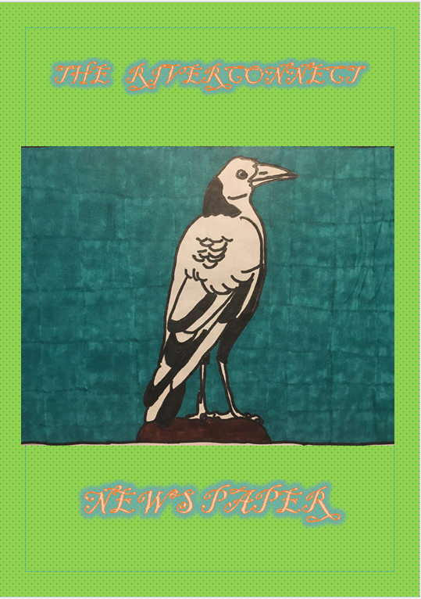

Editor’s note.

During the many difficulties we have all faced during 2020-21, it has been a constant challenge to find new and interesting ways to engage school groups in Environmental Education, with shifts to learning and working from home, online learning, and limitations on in person place based learning. This is not to mention the incredible challenges that teachers and parents have faced in educating students away from their schools during this time, and how difficult this is for some students!
Somewhere along the line, after seeing the fine effort of a local student who had written her own newspaper, I came up with the idea of creating a form of media, to be called the RiverConect News, which would seek contributions from local students about their learnings about our rivers, wetland and bushland, information about what they were interested in and passionate about, to teach others about what they had learned. The aim is that eventually the complete process of creating each edition will be driven and completed by students, with my only role being a facilitator and editor, and occasional provider of a very daggy joke. A news media written by young people for young people. I say ‘media’, as I don’t wish to put assumptions on what form this news should be presented. It can be a traditional newspaper, or a video version more like the TV news, but most likely someone with far better creativity and technical know-how will come up with something new and exciting each time we look to create a new edition so I leave the format open. Edition 1 happens to take the form of a newspaper.
This news media has been just a dream for around a year, with limited interest or take-up, until COVID restrictions shut down a young students dreams of doing projects with RiverConnect out in the environment, caring for the health of our rivers. Not to be deterred, this young student jumped at the chance when I asked whether she’d be interested in having a go at bringing my news idea to life. Many hours of her hard work while learning from home have eventuated in this, the first edition of the RiverConnect Newspaper. I wish to commend Maddy Carter from ACE College for her effort and determination to bring this together despite all the challenges and frustrations. You have done a wonderful job, and I am very thankful!

Allison Trethowan
RiverConnect Education Officer
Editor, RiverConnect Newspaper Edition 1, December 2021.

Student Reporter: Maddy Carter
Logo design: Maddy Carter

A RiverConnect Student Experience.

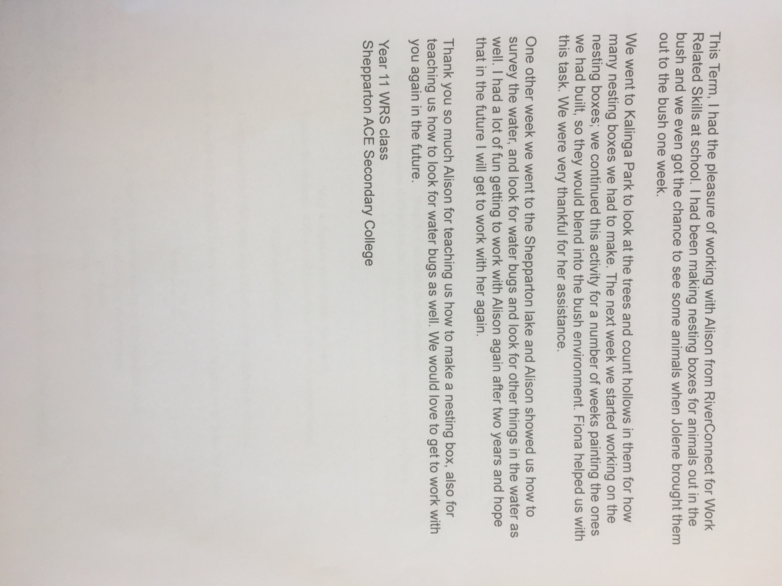

Student and teacher questionnaires.

We got some teachers and students to fill out a questionnaire about when they worked with RiverConnect. The teachers and students will remain anonymous.

Student One.
Have you ever had any previous experience with the RiverConnect program? “Yes I have in year 2, I planted plants”. What skills and knowledge did you develop through working with RiverConnect? “I learnt how to properly plan the plants and how some plants and rivers work”. Do you think the skills and knowledge you learnt through the river connect program will be useful to you in the future? “Yes! I do, it would help if I go out and plants are bad or if I decide to garden”. What activities did you enjoy doing as part of the river connect program? This student ticked the tree planting and also said “i really enjoyed the tree planting because my family love to garden and stuff involving that”. How do you think the community benefits from the RiverConnect program? “It taught us about nature and the way we should treat it and how it works”. What activity did you enjoy the most? “I enjoyed the plant press so, we could press plants from the broken river region”. What would you like to see added or done differently as part of the RiverConnect program? “I am not truly sure I really enjoyed what was there I don’t think anything”. Do you have any other feedback you would you would like to share? “To have elder people to help look after every group so, they don’t do anything wrong or hurt anything”.

Student Two.
Have you had any previous experience with the RiverConnect program? “No I never have but enjoyed it”. What skills and knowledge did you develop through working with RiverConnect? “Well, I really liked that we got to go walking”. Do you think the skills and knowledge you learnt though the RiverConnect program will be useful to you in the future? “Yes because we learned some bush survival skills.” What activities did you enjoy doing as part of the RiverConnect program? This student ticked all of them, so they enjoyed making nesting boxes, tree planting, counting tree hollows, surveying water for aquatic bugs, mapping trees using GPS and getting up close and personal with native animal’s. How do you think the community benefits from the RiverConnect program? “Not sure”. What activity did you enjoy the most? “Putting the bugs in the jars was the best”. What would you like to see added or done differently as part of the RiverConnect program? “Nothing”. Do you have any other feedback you would like to share? “It was fun”

Student Three.
Have you had any previous experience with the RiverConnect program? “Not really, but it was fun”. What skills and knowledge did you develop through working with RiverConnect? “How to survive in the bush”. Do you think the skills and knowledge you learnt through the RiverConnect program will be useful to you in the future? “Yes, I do because it teaches you things”. What activities did you enjoy doing as part of the RiverConnect program? This student ticked all of them, so they enjoyed making nesting boxes, tree planting, counting tree hollows, surveying water for aquatic bugs, mapping trees using GPS and getting up close and personal with native animal’s. How do you think the community benefits from the RiverConnect program? “I’m not sure”. What was the activity did you enjoy the most? “Bugs in jars”.

Teacher One.
Have you had any previous experience with the RiverConnect program? “Yes. In 2019 VCAL intermediate participated in”. What skills and knowledge did you develop through working with RiverConnect? “Using a GPS. Learning about tree hollows, how long they take to develop and the animals that use them”. Do you think the skills and knowledge you learnt through the RiverConnect program will be useful to you in the future? “I explored an area of the river I had not been before so I will definitely return there again. The importance of animal boxes to support animals”. What activities did you enjoy doing as part of the RiverConnect program? This teacher ticked four of them, so they enjoyed tree planting, counting tree hollows, mapping trees using GPS and getting up close and personal with native animals. How do you think the community benefits from the RiverConnect program? “Planting trees benefits everyone providing safe places for our local wildlife is vitally important”. What activity did you enjoy the most? “I enjoyed every aspect. I found the kids counting tree hollows and mapping using the GPS, humorous as they navigated the bush”. What would you like to see or done differently as part of the river connect program? “I think there should be more opportunity to participate”. Do you have any other feedback to you would like to share? “The RiverConnect program is an asset to the community and a great educational opportunity”.

Student Four.
Have you had any previous experience with the RiverConnect program? “No I have never”. What skills and knowledge did you develop through working with RiverConnect? “I learnt about the outback and what (plant) is poisonous”. Do you think the skills and knowledge you learnt through the RiverConnect program will be useful to you in the future? “It depends on where I am”. What activities did you enjoy doing as part of the RiverConnect program? This student ticked three, so they enjoyed making nesting boxes, tree planting and mapping trees using GPS. How do you think the community benefits from the RiverConnect program? “Well they can learn about the bush and water”. What activity did you enjoy the most? “Making the plant press and bird box because it is woodwork”. What would you like to see or done differently as part of the RiverConnect program? “Not a thing it is good already”. Do you have any other feedback you would like to share? “It is the best”.

Teacher two.
Have you had any previous experience with the RiverConnect program? “I have worked with RiverConnect on a number of projects with building animal/critter nesting boxes, evolution of plants and making herbariums with year 7”. What skills and knowledge did you develop through working with river connect? “A great appreciation of our environment in this area and what programs are being developed by RiverConnect”. Do you think the skills and knowledge you learnt through the river connect program will be useful to you in the future? “As a science teacher with a love for biology I have enjoyed the celebrative work with RiverConnect”. What activities did you enjoy doing as part of the RiverConnect program? This teacher ticked all of them so they enjoyed making nesting boxes, tree planting, counting tree hollows, surveying water for aquatic bugs, mapping trees using GPS and getting up close and personal with native animals. How do you think the community benefits from the RiverConnect program? “To develop a better understanding of plants and animals in our local area”. What activity did you enjoy the most? “All, but particularly the herbariums”. What would you like to see added or done differently as part of the RiverConnect program? “Some Indigenous practices that we can all learn”. Do you have any other feedback you would like to share? “This is a wonderful program that I enjoyed participating in”.

Thank you for taking the time to read the first edition of the RiverConnect News. For information about how to get involved and be a driving force behind future editions, please contact Allison Trethowan, RiverConnect Education Officer, on 03 5832 9493, or via email to allison.trethowan@shepparton.vic.gov.au

