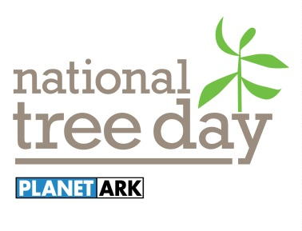
GREATER SHEPPARTON
NATIONAL TREE DAY 2015
Schools Day Friday 24 July
Community Day Sunday 26 July
Expression of Interest Form
Greater Shepparton City Council is calling for Expressions of Interest from Landcare, Community Groups and Local Schools for participation in the National Tree Day 2015. Council has purchased a number of plants and guarding materials for the community to utilise.

To ensure that all groups have an equal opportunity to participate in National Tree Day, Council is requesting that all interested groups complete the form below and return to Greater Shepparton City Council offices by Friday, 12 June 2015.
Please return this form to the Sustainability and Environment Branch, Locked Bag 1000, Shepparton VIC 3632, Fax: (03) 5831 1987 or email: council@shepparton.vic.gov.au

For more information, please contact Travis Turner (03) 5832 9816 or travis.turner@shepparton.vic.gov.au

Group details
Name of school/group
Address
Contact person name
Contact details
Project details
Planting site (please tick) | At school -  Along the river (at your RiverConnect Reach) -  Other -
Number of plants
Plant mix | (eg. 20% trees; 80% shrubs)
Size of area
Soil type (if known) | (eg. Sandy-loam, clay etc)
Ecological Vegetation Community (if known) | (eg. Plains woodland 803)
Pre-planting site preparation | (eg. When will you spray for weeds and rip the ground for planting)
Expected date of planting
Number of people expected on the day
Maintenance of the planting | (eg. How often will you water the plants and who will do it? Follow up weeding?)
Expected outcomes
Other information | (eg. Is the planting adjacent to a stand of native vegetation; is the planting extending a previous planting etc)

